###### APPLIED METAL CUTTING PHYSICS, BEST PRACTICES

*This presentation gives a comprehensive overview of the different physical models used to describe and analyse a machining process and of the basic mechanisms associated with it. A considerable number of practical models and guidelines are outlined. The aim is to provide an adequate understanding of the machining process in different types of workpiece materials. Also a link is made between machining technology and production economics. The primary purpose of this presentation is to give practical models to work towards a productive and cost efficient metal cutting process in different workpiece materials. Most of the relationships, models and guidelines described have been verified experimentally in a wide variety of workpiece materials.*

The behaviour of the machining process is the result of an interaction between the shape and material properties of the workpiece, the geometry of the cutting tool and the properties of the cutting material, the characteristics of the machine tool and auxiliary equipment, as well as the cutting conditions employed. To understand a metal cutting process and the interactions between all the different elements, it is crucial to have an insight into the process conditions which develop between the workpiece and the cutting edge. These process conditions are determined and described by the combination of the mechanical, thermal, chemical and tribological loads.

The interaction between the load situation during the cutting process and the properties of the cutting tool gives a certain tool wear which leads to a certain tool life, which defines a total amount of workpiece material which is removed by a cutting edge under given process conditions. These conditions result in a machining time required for finishing a workpiece with a certain quality, which in turn represents a certain manufacturing cost.

This presentation, together with the STEP book *Applied Metal Cutting Physics, Best Practices*, provides support in training metal cutting professionals, by serving as a source of supplementary knowledge and information. It makes it possible for SECO to educate machining professionals in all parts of the world in a manner that enhances their understanding of a wide variety of metal cutting processes.

**Content of the presentation**

* Introduction
* Process kinematics of a metal cutting process
* General description of a cutting tool
* Machinability models for different workpiece materials
* Chip formation models
* Models for cutting forces
* Thermal analysis of a cutting operation
* Tool deterioration and tool life
* Quality of the machined surface
* Best practices for practical cutting process optimisation
* Economic aspects of cutting processes

**Reference material**

Print-outs of the presentation are not available. Full background information and reference can be found in the book *Applied Metal Cutting Physics, Best Practices* (to be ordered separately or purchased during the presentation).

**About the presenter**

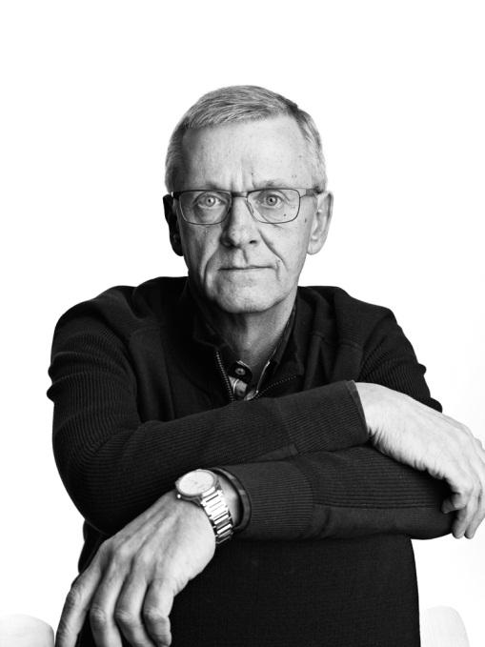Patrick De Vos was born in 1959 in Belgium and graduated from university in 1981; holding a Masters degree in Mechanical and Electrical Engineering (major domain Production Technology).

From 1981 to 1983, he was a post graduate lecturer and researcher (the research subject was optimizing strategies for metal cutting processes and production economics) at a research centre aligned to the university.

From 1983 until 2006, he was employed by Seco Tools Benelux in several technical, commercial, marketing and management positions and was member of several international council groups in Seco Tools. The last position held was Marketing Manager, Technical Education Manager and Manager Seco Benelux Technical Centre.

Since 2006, he has been the Corporate Technical Education Manager for Seco Tools AB. In this position he has lead the creation of STEP (Seco Technical Education Programme) and has the global responsibility for technical education activities for Seco employees and customers worldwide. Since the creation of STEP more than 185,000 people worldwide attended these programmes.

He has personally educated and trained more than 80,000 people in more than 57 countries worldwide during the last 30 years. He has been a guest speaker at many international conventions, conferences and universities worldwide.

He is the author of numerous technical articles on machining techniques and the publications *Metal Cutting, theories in practice, Tool Deterioration, Best Practices* and *Metal Cutting Physics, Best Practices.*

**Practical elements**

* This presentation – in full version - takes about 8 hours presentation time, included question & answer time. Used language is English. If translation is needed, extra time needs to be planned for. If shorter presentation time is available, a light version of selected chapters will be presented.
* This presentation concentrates on metal cutting as a manufacturing process. Product presentation or application description is not included. Questions related to specific product range issues or application conditions shall not be dealt with during the presentation.
* Advisable is to have white board or flip-over available during the presentation.
* Certificates of presence are supplied to the participants.